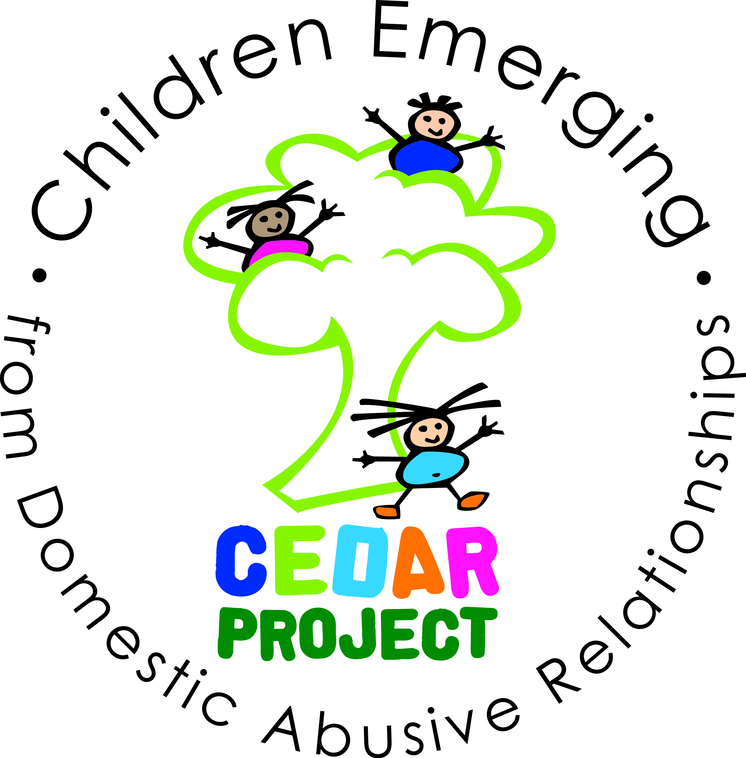
SAFEGUARDING CHILDREN POLICY

- RATIONALE
At CEDAR Prime we ensure that children are safeguarded by robust and efficient child protection and recruitment systems and procedures. We believe that high quality dedicated staff are the key to a successful Project, and we will ensure that all staff are recruited following correct and thorough vetting procedures.

This policy has been adapted from Bournemouth Borough Council’s Policy to ensure that best practice and procedures are carried out at the Project. This policy complies with the requirements of the Local Safeguarding Children’s Board. We adhere to the LSCB Guidance for Safer Working Practice for Adults Who Work with Children & Young People. Our designated Child Protection Officer is Peter Webber.

Aims
- To help children to establish and sustain positive and fulfilling relationships within their families, with peers and with other adults;
- To encourage children to develop a sense of autonomy and independence;
- To enable children to have the self confidence and the vocabulary to resist inappropriate approaches;
- To work with parents to build their understanding of and commitment to the welfare of all our children;
- To assist families in identifying their child’s needs, through completing a CAF (Common Assessment Framework) and adopting a multi-agency approach to support when necessary

- DEFINITION OF ABUSE
We recognise the Department of Health’s definitions of abuse in their booklet ‘What to do if you’re worried a child is being abused’ (2006):
A person may abuse or neglect a child by inflicting harm, or by failing to act to prevent harm. Children or young people may be abused in a family or in an institutional or community setting; by those known to them or, more rarely, by a stranger.

- Physical Abuse may involve hitting, shaking, throwing, poisoning, burning or scalding, drowning, suffocating, or otherwise causing physical harm to a child, including by fabricating the symptoms of, or deliberately causing, ill health to a child.
- Emotional Abuse is the persistent emotional ill-treatment of a child such as to cause severe and persistent adverse effects on the child’s emotional development. It may involve conveying to children that they are worthless or unloved, inadequate or valued only insofar as they meet the needs of another person, age or developmentally inappropriate expectations being imposed on children, causing children frequently to feel frightened, or the exploitation or corruption of children.
- Sexual Abuse involves forcing or enticing a child or young person to take part in sexual activities, whether or not the child is aware of what is happening. The activities may involve physical contact, including penetrative (e.g. rape, buggery) or non penetrative acts. They may include involving children in or looking at, or in the production of, pornographic material, or encouraging children to behave in sexually inappropriate ways.
- Neglect is the persistent failure to meet a child’s basic physical and/or psychological needs, likely to result in the serious impairment of the child’s health or development, such as failing to provide adequate food, shelter and clothing, or neglect of, or unresponsiveness to, a child’s basic emotional needs.

- OUR COMMITMENT
We will:
- Ensure that all members of staff at payed and voluntary are diligent and understand clearly the need for strong child protection procedures which are vigorously implemented and followed.
- Ensure that all Members of staff at the Project will be vigilant and understand how to identify possible signs of abuse.
- Ensure appropriate ratios and experienced staffing resources to meet the needs of children.
- Ensure that there is excellent communication at all levels which results in a swift response and cohesive action to safeguard the child or adult by a range of partner agencies and professionals.
- Adhere to Safer Recruiting procedures when appointing staff and volunteers and ensure thorough checking and vetting procedures prior to commencing an appointment at the Project.
- Ensure that Parents, carers and professionals understand the responsibility of the Project for protecting children.
- Maintain detailed written records of any child protection and safeguarding incidents including any action taken as a result.

- PREVENTION
We will:
- Seek to maintain an ethos where children feel secure, are encouraged to talk and are listened to.
- Ensure that children know that there are adults in the Project whom they can approach if they are worried or in difficulty.
- Include in the activities and services learning opportunities for personal, social and emotional education which will help provide children with the skills and confidence they need to stay safe and know who to turn to if they require assistance and support.

- RESPONDING TO SUSPICIONS OF ABUSE AND DISCLOSURES
- We acknowledge that abuse of children can take different forms – physical, emotional, sexual and neglect.
- When children are suffering from physical, sexual or emotional abuse, this may be demonstrated through changes in their behaviour, or in their play. Where such changes in behaviour occur, or where children’s play gives cause for concern, we follow the Safeguarding procedure.
- Where a child shows signs and symptoms of ‘failure to thrive’ or neglect, we make appropriate referrals.

Where a child makes a disclosure to a member of staff, that member of staff:
- offers reassurance to the child;
- listens to the child;
- gives reassurance that he or she will take action; and
- does not question the child.

- RECORDING SUSPICIONS OF ABUSE AND DISCLOSURES
Staff make a record of:
- The child’s name;
- The child’s address;
- The age of the child;
- The date and time of the observation or the disclosure;
- An objective record of the observation or disclosure;
- The exact words spoken by the child;
- The name of the person to whom the concern was reported, with date and time; and
- The names of any other person present at the time.

The concern is discussed with the Local Safeguarding Lead and action taken as appropriate (e.g. monitoring, referral). The records are signed and dated and kept in the Safeguarding Folder in a locked cupboard in the Project office.

- INFORMING PARENTS
Parents are normally the first point of contact. If a suspicion of abuse is recorded, parents are informed at the same time as the report is made, except where the guidance of the LSCB does not allow this. This will usually be the case where the parent is the likely abuser. In these cases the investigating officer will inform parents.

With the proviso that the care and safety of the child is paramount, we will do all in our power to support and work with the child’s family.

- CONFIDENTIALITY
All suspicions and investigations are kept confidential and shared only with those who need to know. Any information is shared under the guidance of the LSCB.

- ALLEGATION AGAINST A MEMBER OF STAFF
We follow the guidance of the LSCB when investigating any complaint that a member of staff or volunteer has abused a child or young person.

Any allegation against a member of staff will be treated seriously. Details will be passed on to the local authority designated officer, and will be dealt with in line with borough procedures. No investigation will take place at the Project. The member of staff may be suspended pending the outcome of the investigation.

- SUPERVISION OF VOLUNTEERS
Procedures are in place to ensure volunteers are not left alone with children. Volunteers are supervised by a member of staff at all times.

- RECRUITMENT OF STAFF AND VOLUNTEERS
We are committed to recruiting, appointing and employing staff and volunteers in accordance with all relevant legislation and best practice.

We adhere to the LSCB Safer Recruitment Procedures http://bournemouth-poole-lscb.org.uk/inter-agency_safeguarding_procedures/chapter_4

- All staff members attend Safeguarding Children training on appointment and refresher courses every 3 years.
- All posts within the Project are exempt from the Rehabilitation of Offenders Act in 1974. Staff and volunteers must have an Enhanced DBS check before commencing work at the Project. Where applicants are rejected because of information that has been disclosed, applicants have the right to know and to challenge incorrect information.
- Any allegation made against a member of staff will be taken seriously and dealt with in accordance with LSCB Procedures. (See Allegations Against Staff procedure)
- We abide by the Protection of Children Act requirements in respect of any person who is dismissed from our employment, or resigns in circumstances that would otherwise have lead to dismissal for reasons of child protection concern.

- TRAINING
We seek out training opportunities for all adults involved working with children or young people at the Project to ensure that they are able to recognise the signs and symptoms of possible physical abuse, emotional abuse, sexual abuse, neglect and domestic violence and that they are aware of the local authority guidelines for making referrals.

We ensure that all staff know the procedures for reporting and recording their concerns in the Project. As well as LSCB guidance documents, staff can also refer to the Department of Health book ‘What to do if you’re worried a child is being abused’. Staff and Volunteers are made aware of where all relevant documents are kept on induction.

- WHISTLE BLOWING
CEDAR Prime welcomes legitimate concerns to be raised in respect of malpractice without fear of victimisation, subsequent discrimination or disadvantage.

Any member of staff or member of the public can report concerns regarding malpractice of a member of staff.
In the event that any person feels unable to raise their concerns with directly with the Project, they may wish to report their concerns to the local Police.
- THE LEGAL FRAMEWORK
- The Rehabilitation of Offenders Act 1974
- The Children Act 1989 and 2004
- Human Rights Act 1998
- Data Protection Act 1984
- The Protection of Children Act 1999
- United Nations Convention on the Rights of the Child 1989

